## Artificial Intelligence

Assignment -5 Report

Kaushik Dey

MT22034

Contents

* Pre-processing steps
* Explanation of the code and output

Pre-processing of the Program

Step1: Take the input from the user in form of natural language using python.

Step2: Performed stop word removal, lemmatization, ngram conversion and lowercase conversion.

Step3: From the ngram list each important information was searched through substring comparison method and then written to a file prolog file as facts .

Explanation of the code

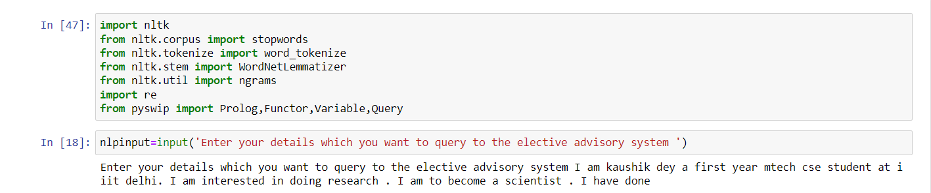

imported all the desired libraries and taken the input from the user .

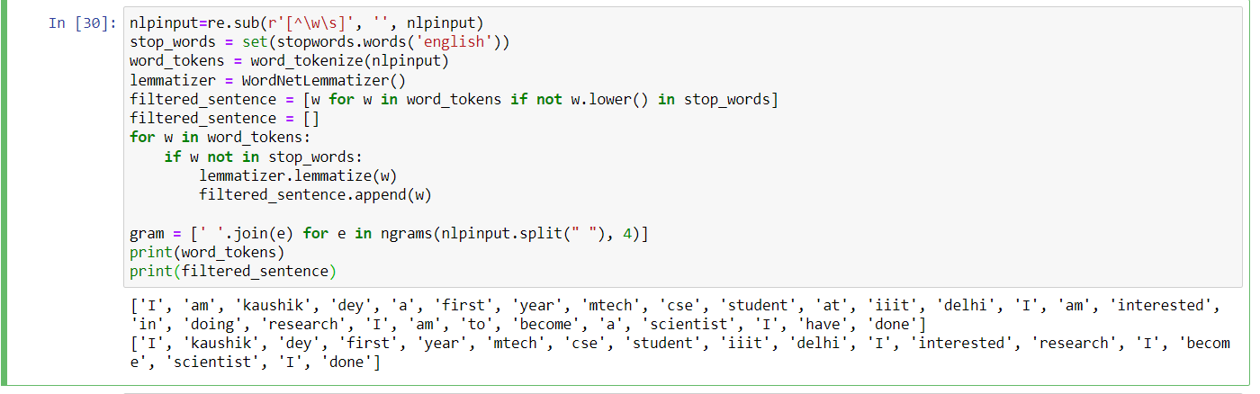

Lemmatized and removed stopwords and also used ngrams taking n as 4.

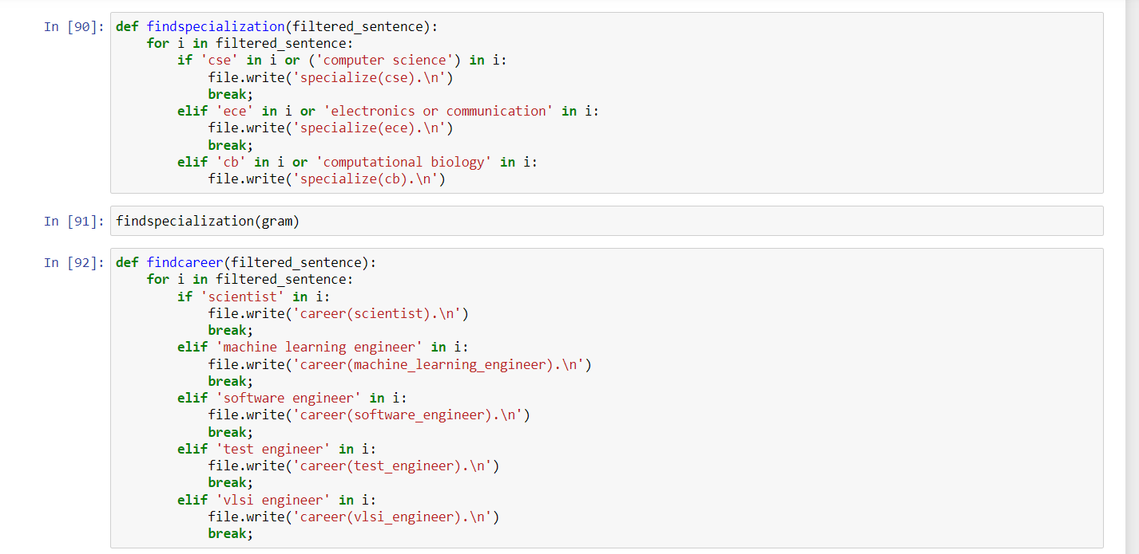

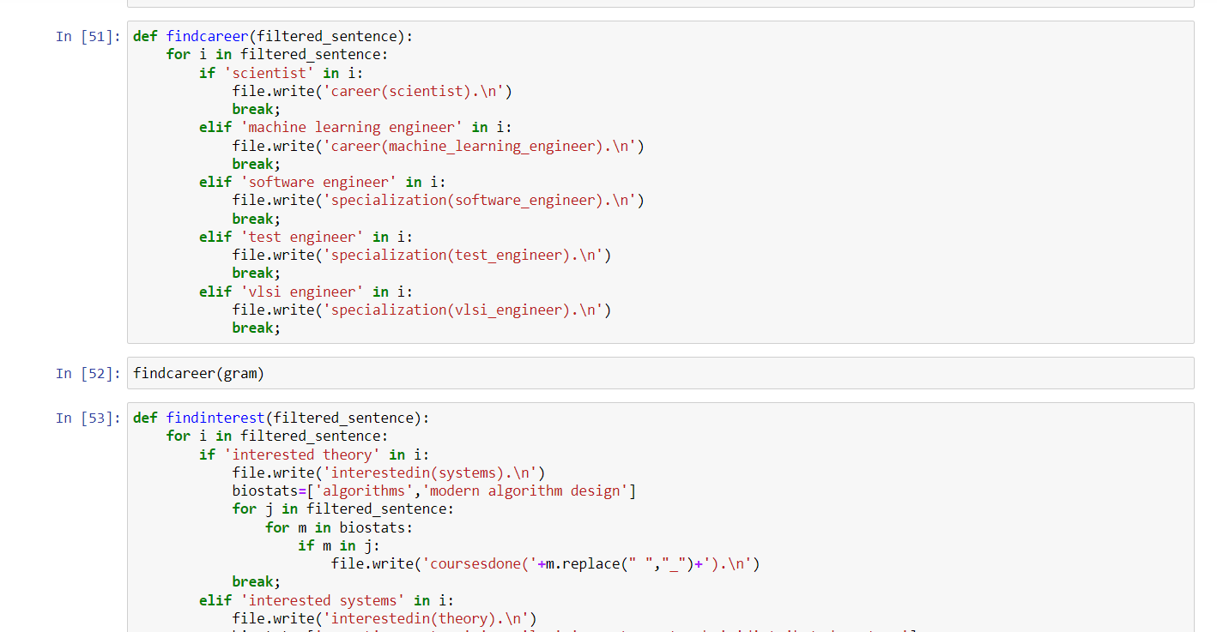

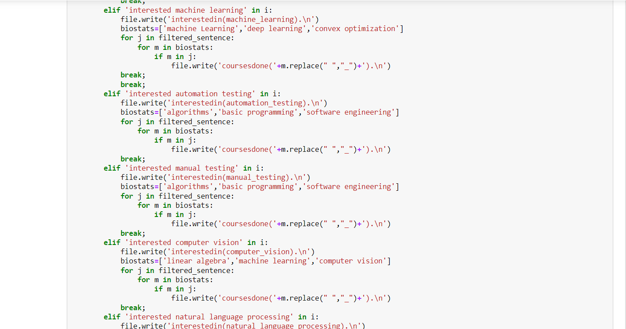

Searched for interest .

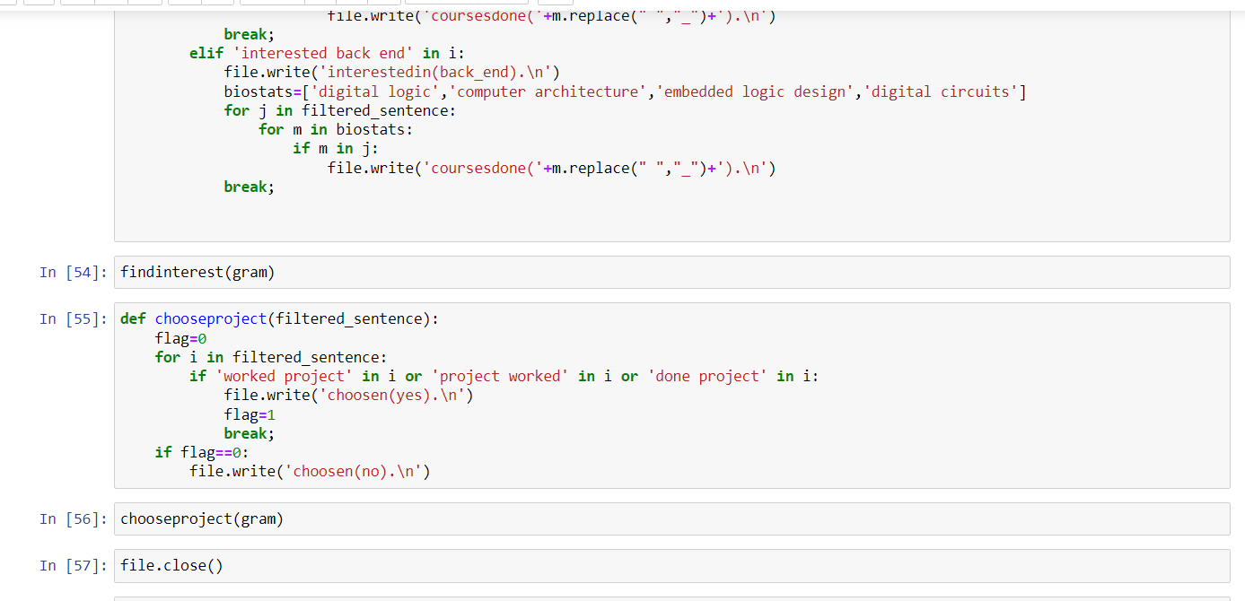

Checked whether user has done any project or not. Closed the file .

The facts file.

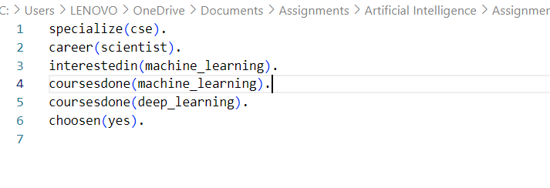

Output

